Contents

Introduction 4

Task 1: 5

Explain about the version of html you have used HTML 5 5

Screenshot of the doctype declaration of any page 5

Screenshot of your home page in any of the two web browsers. 6

Screenshot with screen resolutions of 1024x768 without users having to scroll horizontally. 7

Screenshot of horizontal hover able navigation bar with drop-down menus 7

Screenshot of passenger drop-down list on the home page 8

Screenshot of the HTML form – HTML CODE OF THE FORM 8

Screenshot of the HTML form – INTERFACE OF THE HTML FORM 10

Screenshot of CSS used for html form. 10

Screenshot of the multimedia elements used. 12

Explain about the types of images used. Explain why you have used particular type of image instead of other types 13

Explain about the accessibility features used in your media. 13

CSS3 media query codes 13

Task 2 17

Explain about the way you have used CSS. 17

Screenshot of the linked section (CSS link with html) 17

Explain about the CSS selectors. 17

CSS screenshots 18

CSS code for Horizontal Navigation Bar with dropdowns. 28

CSS code for image gallery for the Explore page. 29

Task 3 31

Explain about the validation and browser testing. 31

Screenshot of each html page after successful validation testing. 31

Screenshot of css file after successful validation testing. 36

Describe your findings. 36

Screenshot of any page in two different browsers. (1024*768 screen resolution) 37

Explain if there is any difference in the outputs (in two browsers). You can explain about the problems you have faced while checking in different browsers. If you find any problems, provide a description of any outstanding problems and recommendations for fixing them. 39

Task 4 40

Analysis of the website 40

Effectiveness of the CSS for the hover able horizontal navigation bar 40

Evaluation of the passenger drop-down list and options 40

Advantages and disadvantages of various types of multimedia file formats 40

Advantages and disadvantages of different types of multimedia elements in relation to different contexts 41

Advantages and disadvantages aspects of your website, suggest improvements, and propose ideas for further development. 41

Conclusion 41

References 42

FIGURES

Figure 1: Screenshot of doctype declaration 5

Figure 2: Screenshot of homepage in Internet Explorer 6

Figure 3: Screenshot of homepage in Google Chrome 6

Figure 4: Screenshot of 1024 x768 without scroll horizontal 7

Figure 5: Screenshot of horizontal hover able navigation bar with drop-down menus 7

Figure 6: Screenshot of passenger drop-down list on the home page 8

Figure 7: Screenshot of the HTML form code 9

Figure 8: Screenshot of the HTML form 10

Figure 9: Screenshot of CSS used for html form. 12

Figure 10: Screenshot of the multimedia elements. 12

Figure 11: Screenshot of CSS3 media codes 16

Figure 12: Screenshot of CSS link with html 17

Figure 13: CSS codes 27

Figure 14: Screenshot of CSS code for Horizontal Navigation Bar with dropdowns. 28

Figure 15: Screenshot CSS code for image gallery for the Explore page. 30

Figure 16: Screenshot of aboutus.html after successful validation testing 31

Figure 17: Screenshot of arrival.html after successful validation testing 32

Figure 18: Screenshot of checkin.html after successful validation testing 32

Figure 19: Screenshot of departure.html after successful validation testing 33

Figure 20: Screenshot of explore.html after successful validation testing 33

Figure 21: Screenshot of faq.html after successful validation testing 34

Figure 22: Screenshot of flight.html after successful validation testing 34

Figure 23: Screenshot of index.html after successful validation testing 35

Figure 24: Screenshot of mobileapps.html after successful validation testing 35

Figure 25: Screenshot of budget.css after successful validation testing 36

Figure 26: Screenshot of arrival in google chrome 37

Figure 27: Screenshot of check-info in google chrome 37

Figure 28: Screenshot of arrival in internet explorer 38

Figure 29: Screenshot of check-info in internet explorer 38

# Introduction

Budget flights is a new airline company in the market offering cheap travel across. The airline company have decided to develop a website which will initially allow customers to search for flights. I have used Notepad++, HTML and CSS to develop the website of budgetflights.

I have used HTML and CSS to develop a user-friendly website for budget flights. HTML stands for Hypertext Markup Language which defines the structure and information of web content. HTML alone cannot develop a perfect website so, CSS plays the vital role to design and decorates the HTML content. CSS stands for Cascading Style Sheets which used to define styles for web pages, layout and variations in the display for different devices and screen sizes. We can find different website development software in the market but I have used notepad++ because it is open source software which used text and source code editor and also works with multiple open files in a single window.

# Task 1:

## Explain about the version of html you have used HTML 5

I have used HTML5 which is the revised edition of HTML, used for constructing and launching content on the WWW. Features of htm5 are

* Supporting accessibility and [responsive design](https://www.google.com/search?q=responsive+design&sa=X&ved=2ahUKEwig9dq43e_fAhXLrI8KHX9XD1sQ1QIoAHoECAAQAQ).
* Encouraging semantic rather than appearance.
* Break off design from content. (TO THE NEW BLOG, 2019)

## Screenshot of the doctype declaration of any page

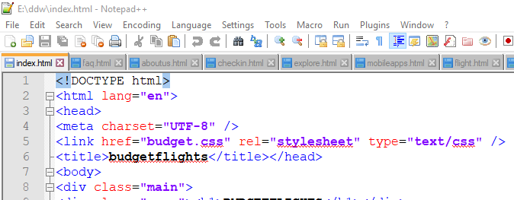

Figure 1: Screenshot of doctype declaration

## Screenshot of your home page in any of the two web browsers.

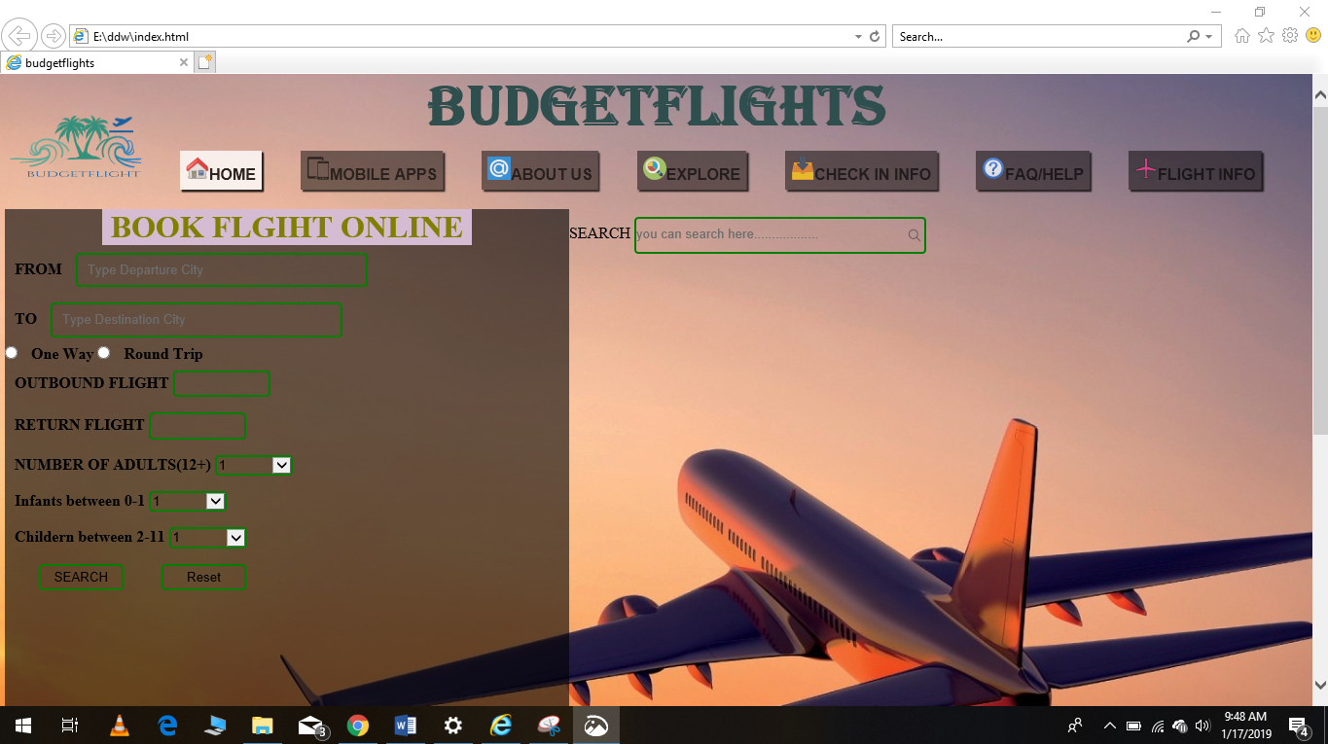

Figure 2: Screenshot of homepage in Internet Explorer

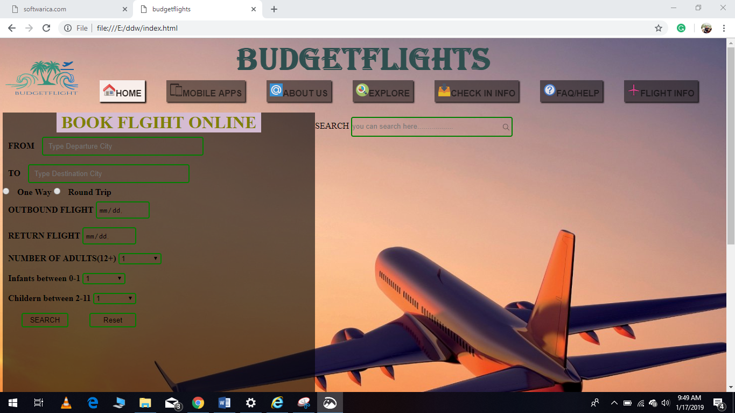

**Figure 3: Screenshot of homepage in Google Chrome**

## Screenshot with screen resolutions of 1024x768 without users having to scroll horizontally.

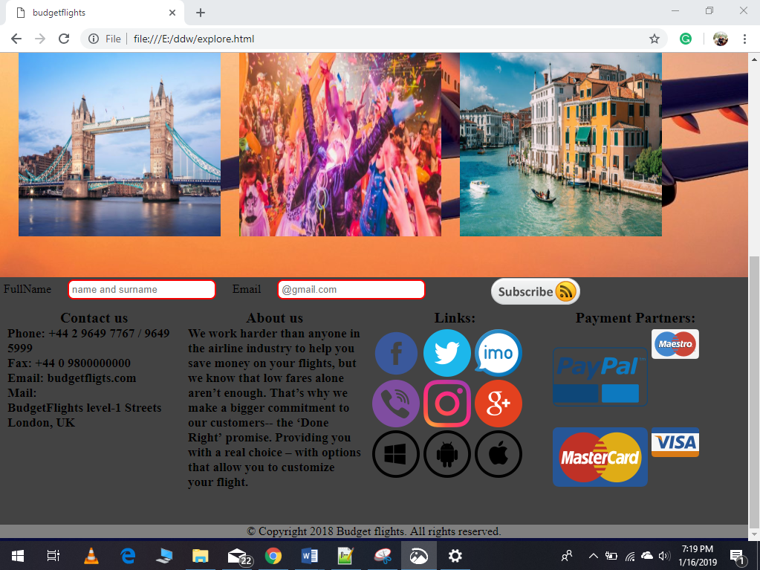

Figure 4: Screenshot of 1024 x768 without scroll horizontal

## Screenshot of horizontal hover able navigation bar with drop-down menus

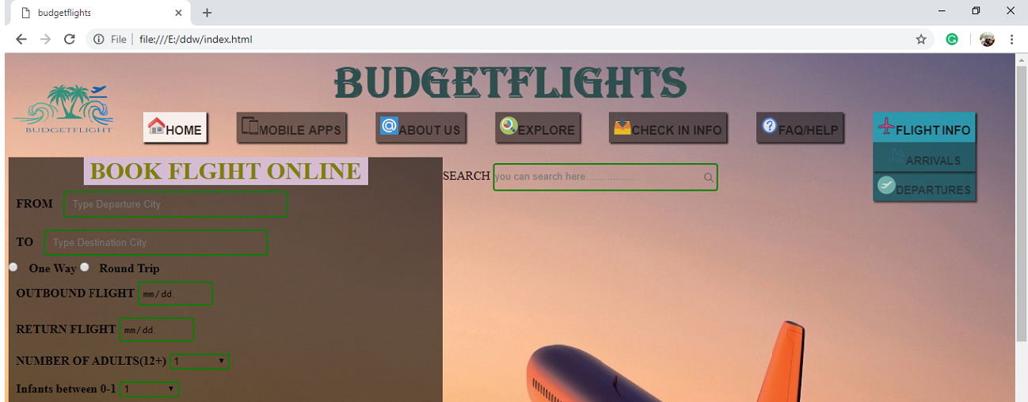

Figure 5: Screenshot of horizontal hover able navigation bar with drop-down menus

## Screenshot of passenger drop-down list on the home page

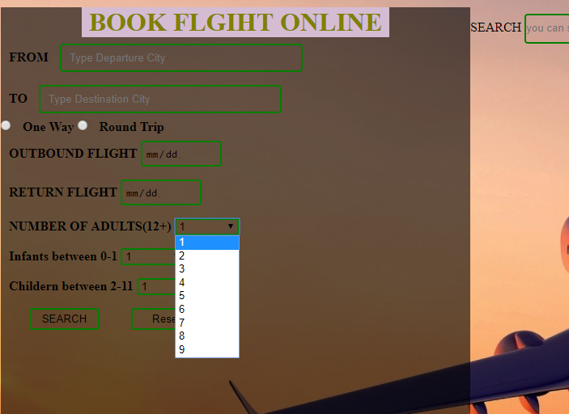

Figure : Screenshot of passenger drop-down list on the home page

## Screenshot of the HTML form – HTML CODE OF THE FORM

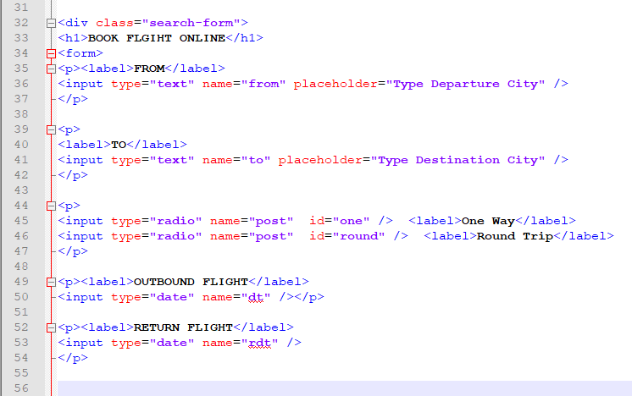

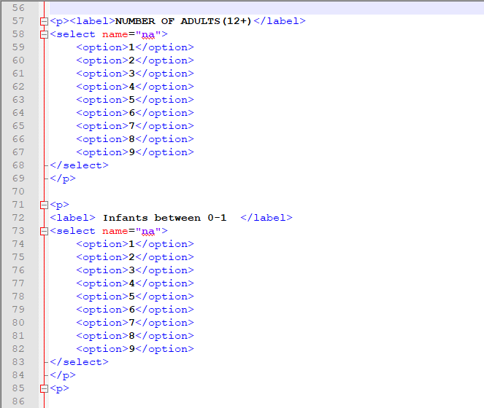

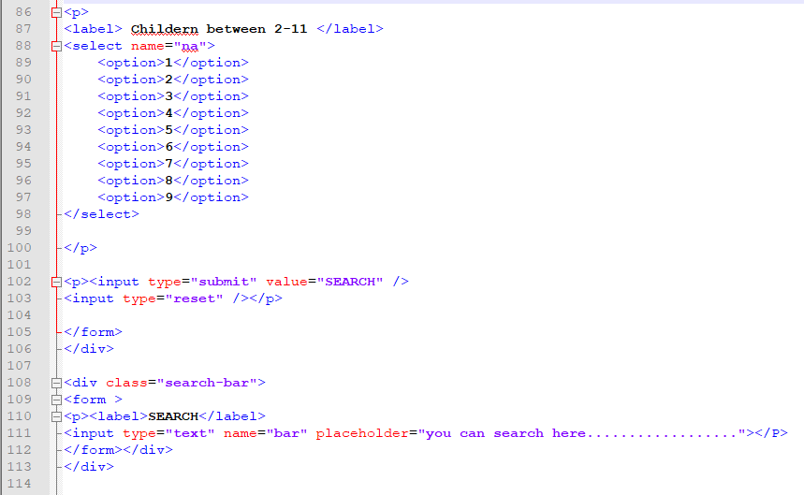

Figure : Screenshot of the HTML form code

## Screenshot of the HTML form – INTERFACE OF THE HTML FORM

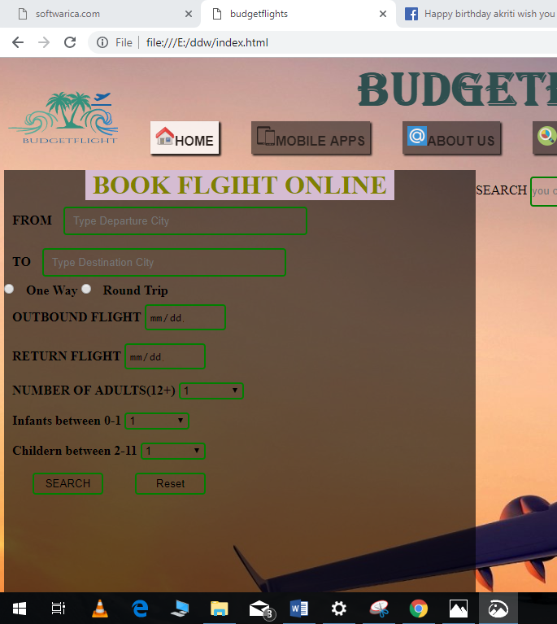

Figure : Screenshot of the HTML form

## Screenshot of CSS used for html form.

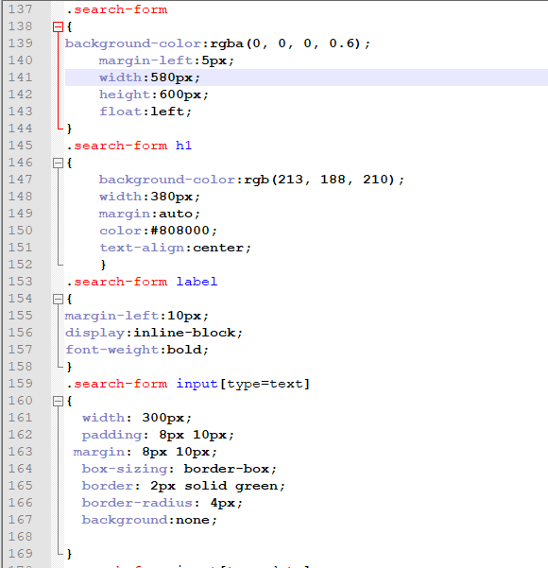

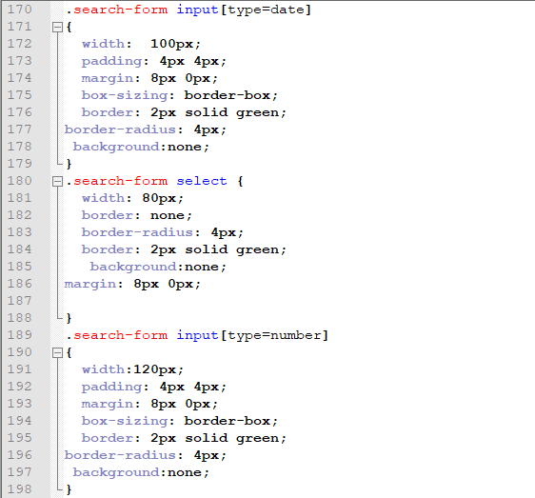

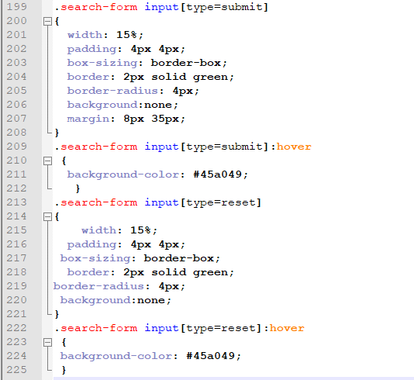

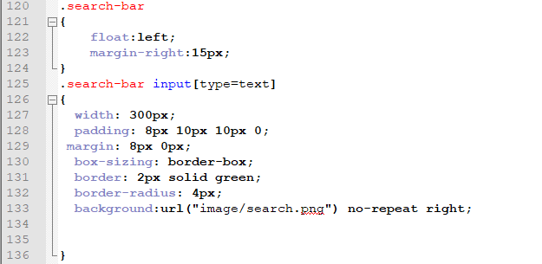

Figure : Screenshot of CSS used for html form.

## Screenshot of the multimedia elements used.

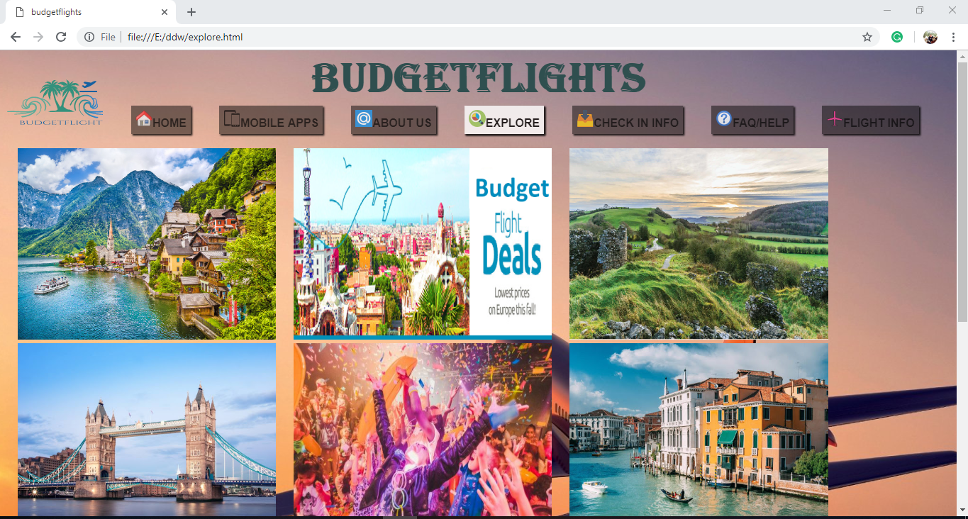

**Figure 10: Screenshot of the multimedia elements**.

## Explain about the types of images used. Explain why you have used particular type of image instead of other types

There are different types of image formats such as GIF, BMP, PNG, and JPEG. In this project, I have mainly used 2 types of images. They are

**Jpg:** I have used jpg images because jpg images compressed a lot of information to store in a small-size file. JPG images are in 24-bit and very appropriate for a wide range of colors.

**Png:** PNG images are used in my project because it allows for a full range of color and better compression.PNG are in 8-bit 16-bit or 24 bit .8-bit image has more advantage then gif because it has transparency and smaller file size than GIF. (Solutions, 2019)

## Explain about the accessibility features used in your media.

The accessibility features used in media are mentioned below:

* Media query was used to make responsive on 1024x768 resolution.
* User can search flight using mobile apps or website.
* User can get information, FAQ and also explore Europe.
* User can check arrival and departure of flight.

## CSS3 media query codes

Media query is standard method to adjust style according to the screen resolution, device compatible.

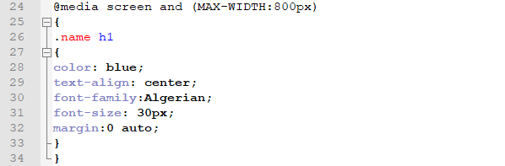

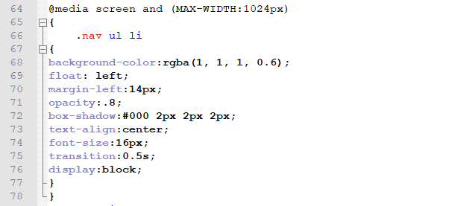

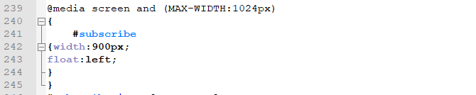

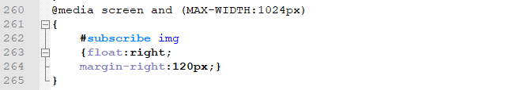

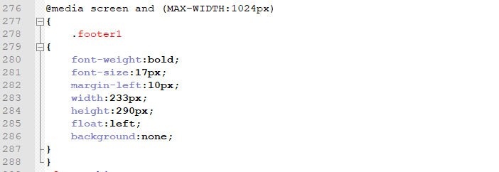

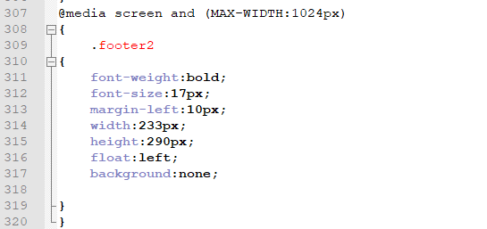

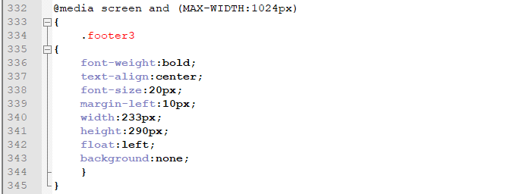

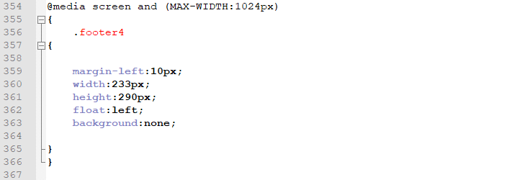

Figure : Screenshot of CSS3 media codes

# Task 2

## Explain about the way you have used CSS.

External css is a separate file linked to an HTML web page. There are 3 types of css. They are internal, external and inline css. External css can be linked from HTML pages. When using an external css, styles need to be set up only once for each element. It has faster loading speed.

## Screenshot of the linked section (CSS link with html)

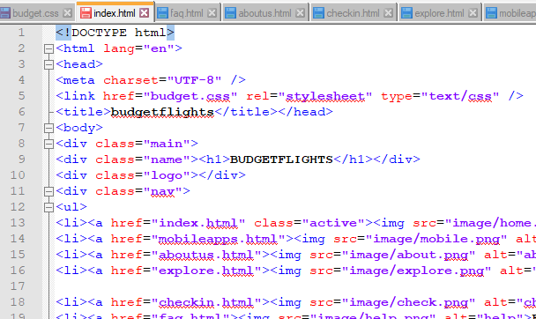

Figure : Screenshot of CSS link with html

## Explain about the CSS selectors.

A CSS selector is sets of the rule that actually selects the web page content to style. Some CSS selectors are briefly mentioned below:

**Id**: ID selector is an element that matches an id defined in an id attribute in the HTML. It indicates by (#ID).

**Class**: Class selector is an element that matches an id defined in an id attribute in the HTML. It indicates by (.class).

**Inheritance**: In this type of selector there is nesting between child and parent elements.

**Multiple selectors:** The selector in which multiple child elements can be controlled by using one selector

**Descendant:** The selector which is used to separate two or more selector by white space.

## CSS screenshots

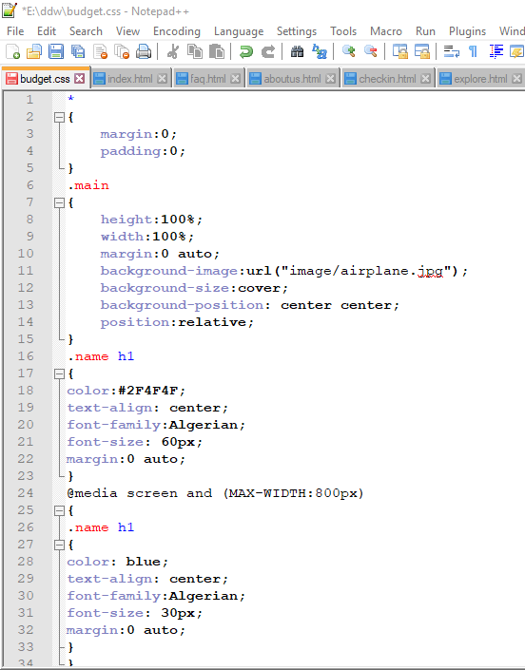

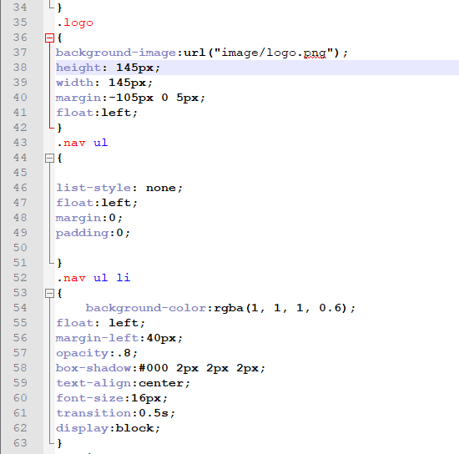

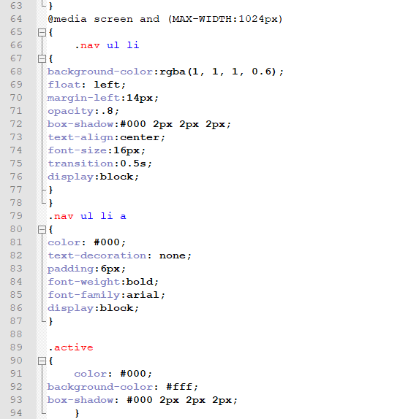

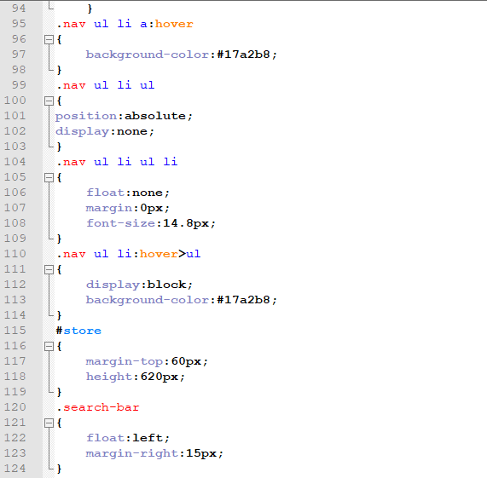

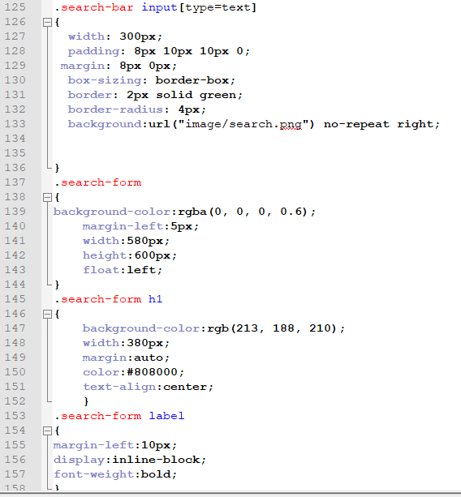

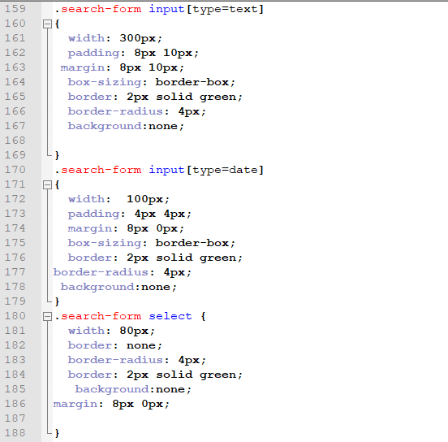

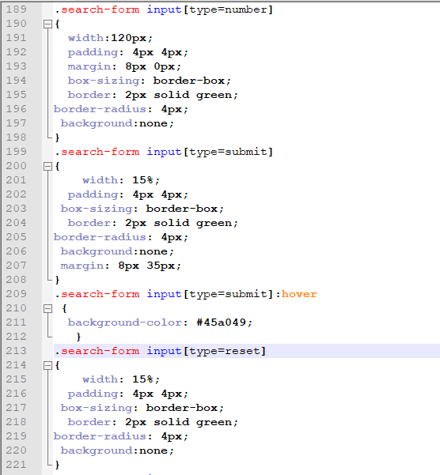

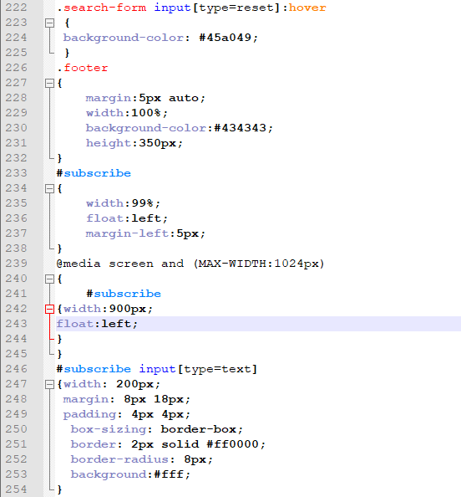

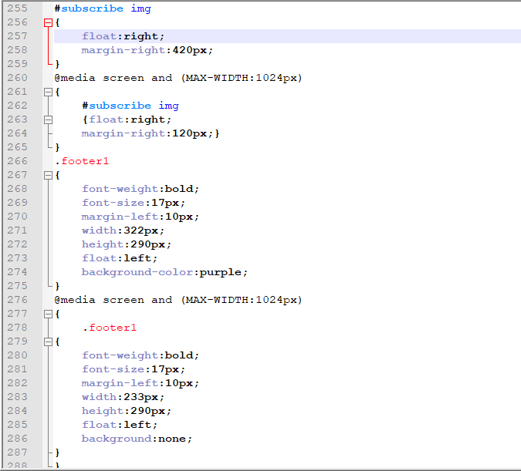

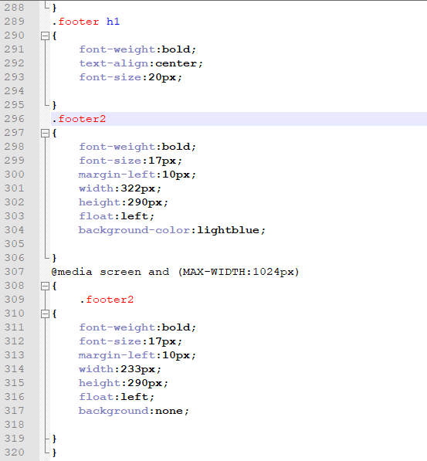

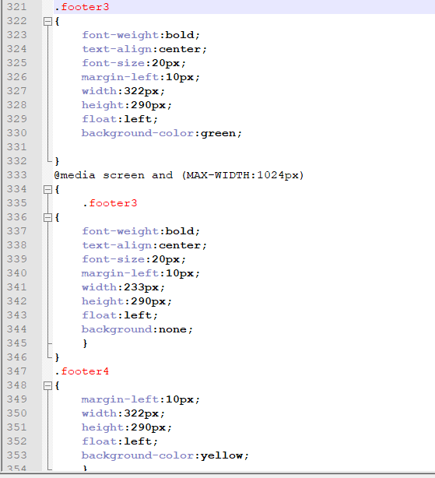

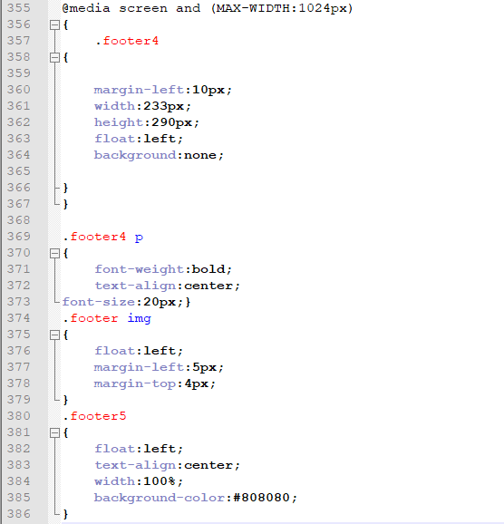

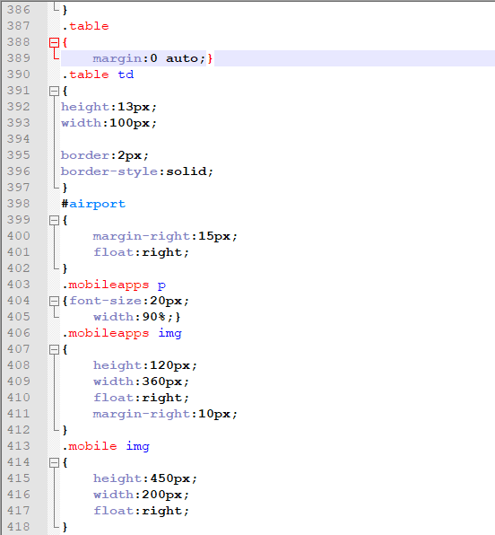

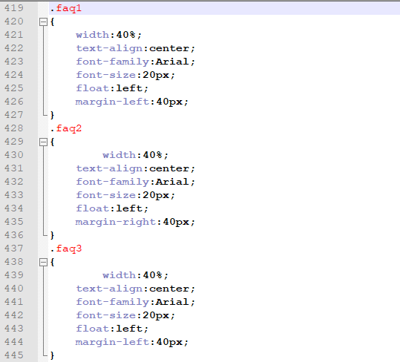

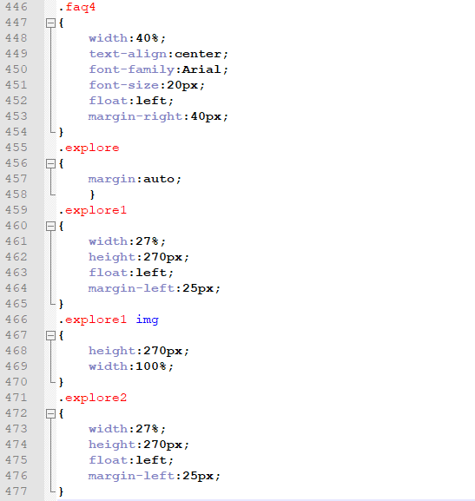

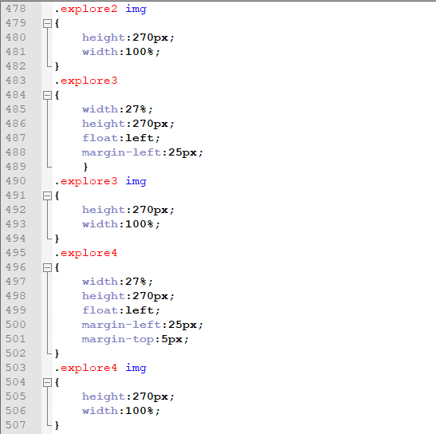

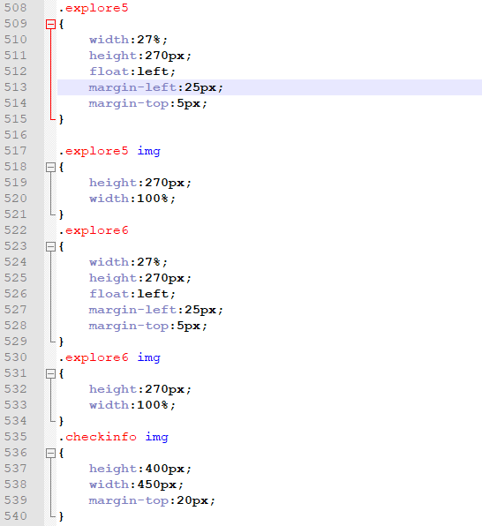

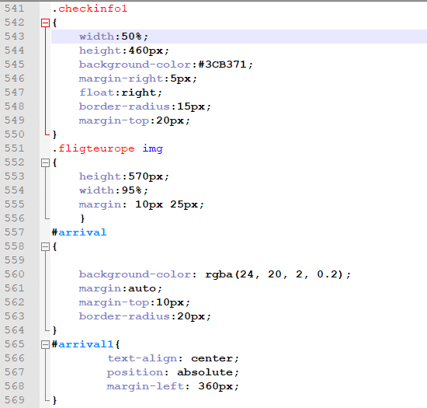

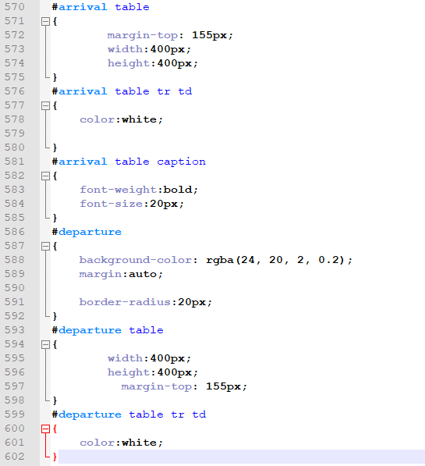

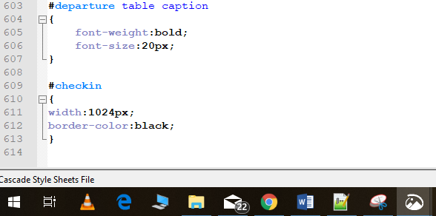

Figure : CSS codes

## CSS code for Horizontal Navigation Bar with dropdowns.

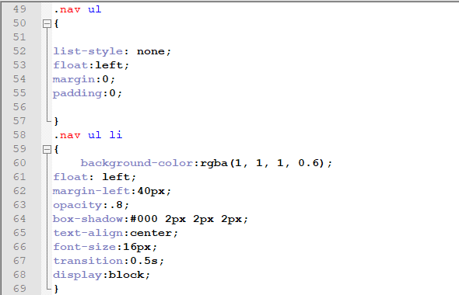

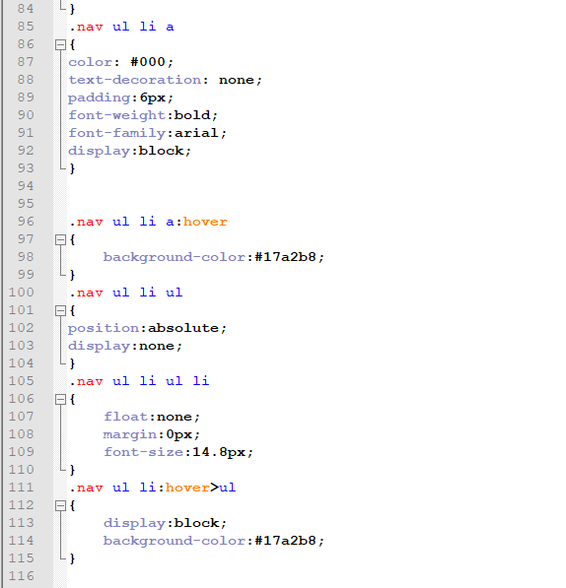

Figure : Screenshot of CSS code for Horizontal Navigation Bar with dropdowns.

## CSS code for image gallery for the Explore page.

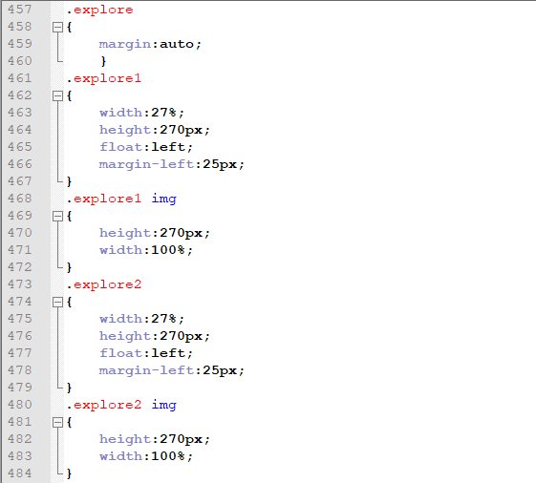

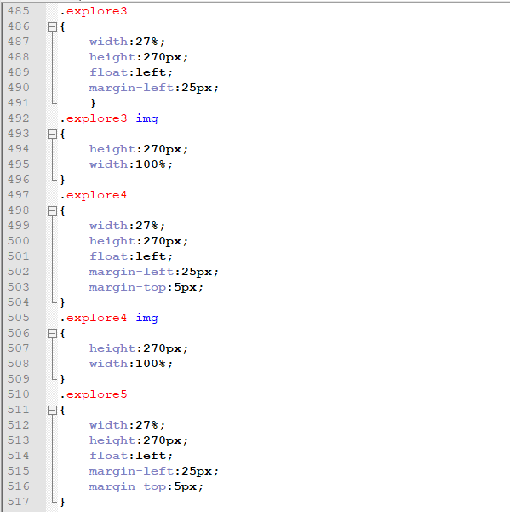

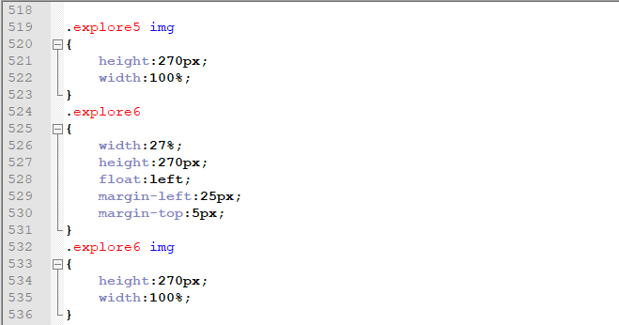

Figure : Screenshot CSS code for image gallery for the Explore page.

# Task 3

## Explain about the validation and browser testing.

Verifying norms or standard defined by a particular organization is the process of validation. The main purpose of validation is to spot an error in HTML or CSS. I have used w3validator for the validation of my webpage.

Browser testing is the process of the testing webpage in multiple web browser. The main purpose of browser testing is to check whether there any appearance difference or not.

## Screenshot of each html page after successful validation testing.

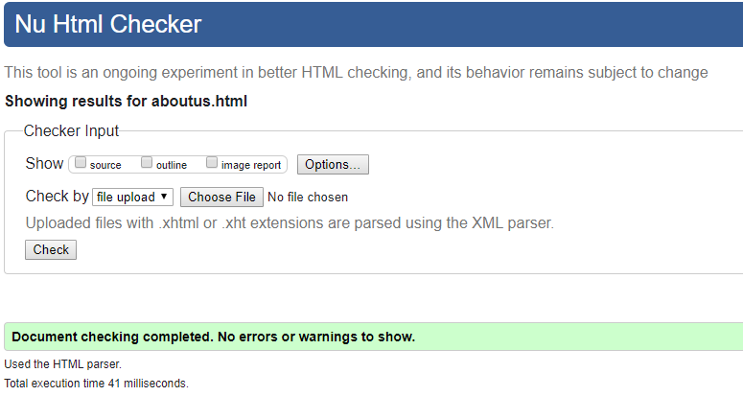

Figure : Screenshot of aboutus.html after successful validation testing

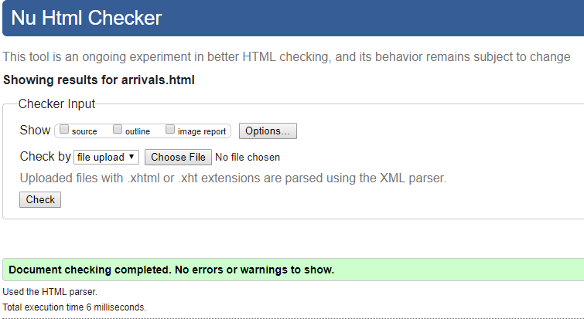

Figure : Screenshot of arrival.html after successful validation testing

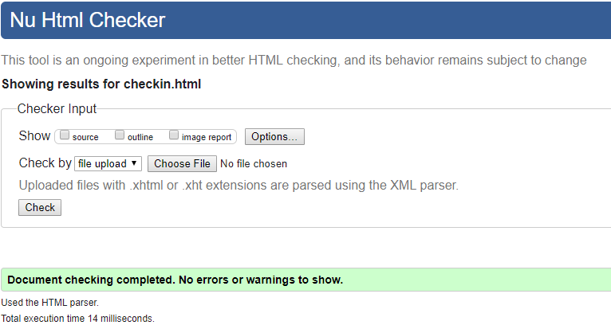

Figure : Screenshot of checkin.html after successful validation testing

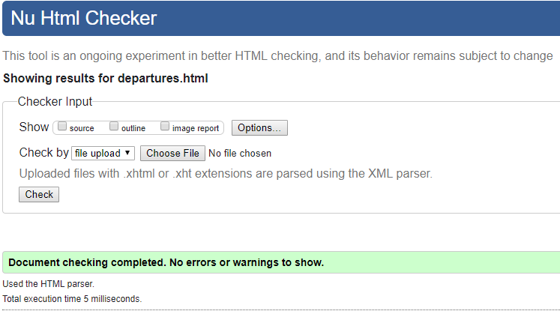

Figure : Screenshot of departure.html after successful validation testing

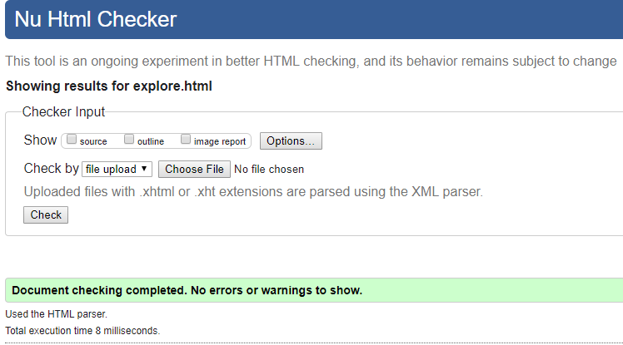

Figure : Screenshot of explore.html after successful validation testing

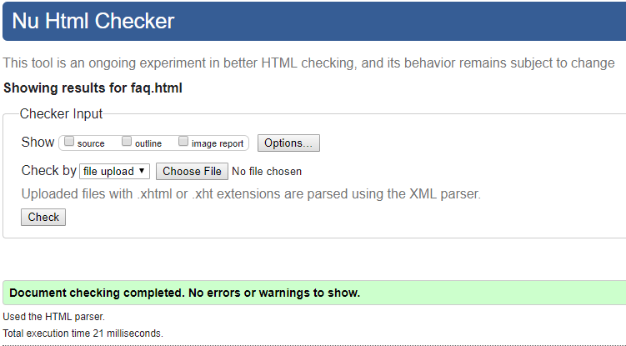

Figure : Screenshot of faq.html after successful validation testing

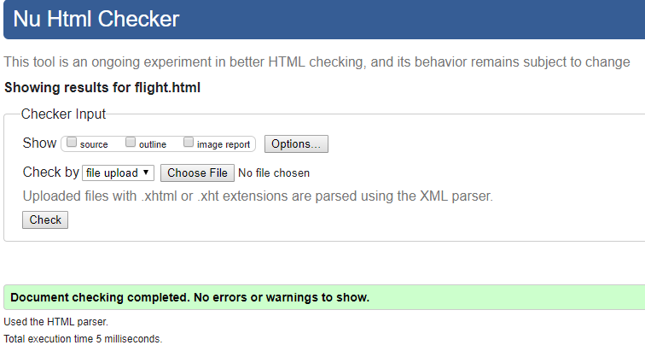

Figure : Screenshot of flight.html after successful validation testing

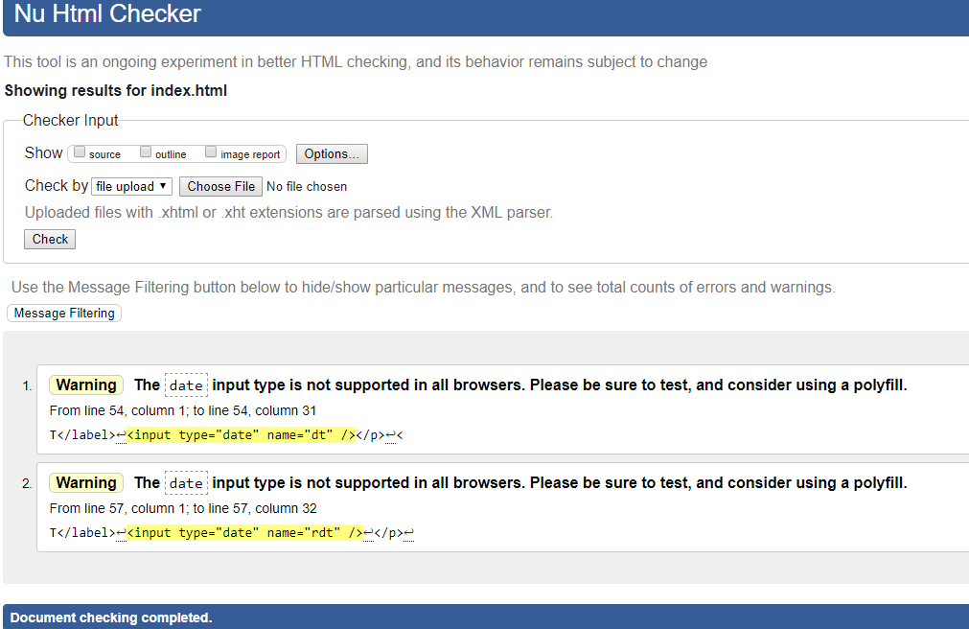

Figure : Screenshot of index.html after successful validation testing

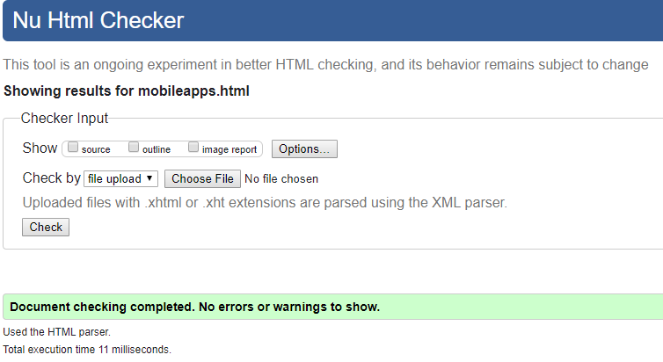

Figure : Screenshot of mobileapps.html after successful validation testing

## Screenshot of css file after successful validation testing.

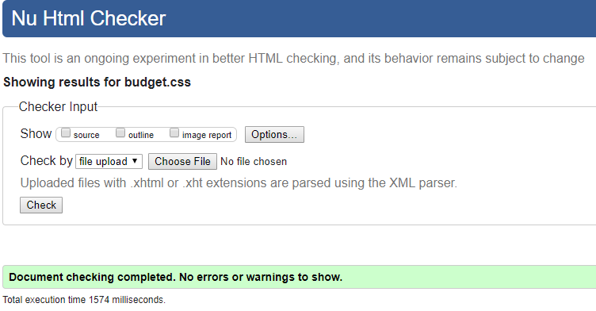

Figure : Screenshot of budget.css after successful validation testing

## Describe your findings.

While testing our HTML and CSS I have found some errors and problems like some tag were not supported by some browsers. Many errors are shown by the validator which is rechecked and solved. HTML and CSS were validated by using w3validator and make standard websites.

## Screenshot of any page in two different browsers. (1024*768 screen resolution)

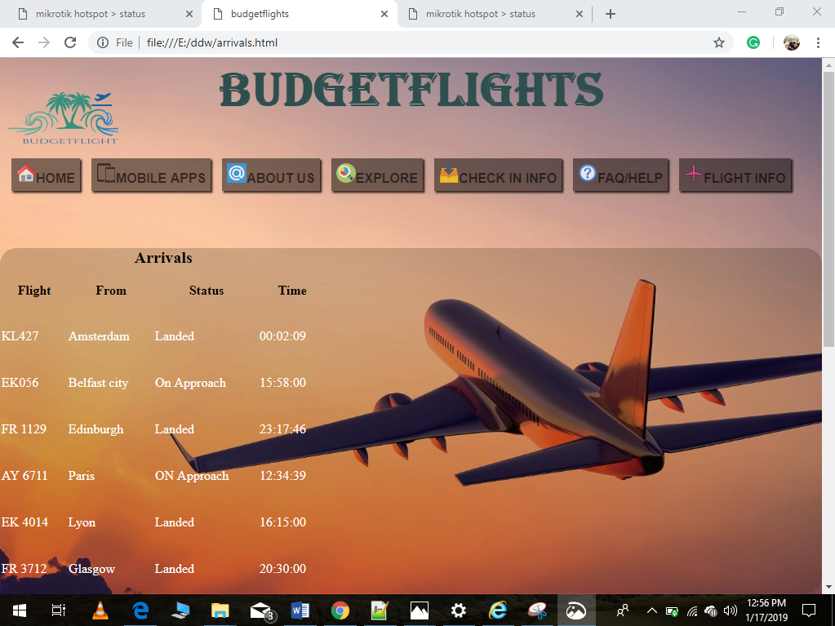

Figure : Screenshot of arrival in google chrome

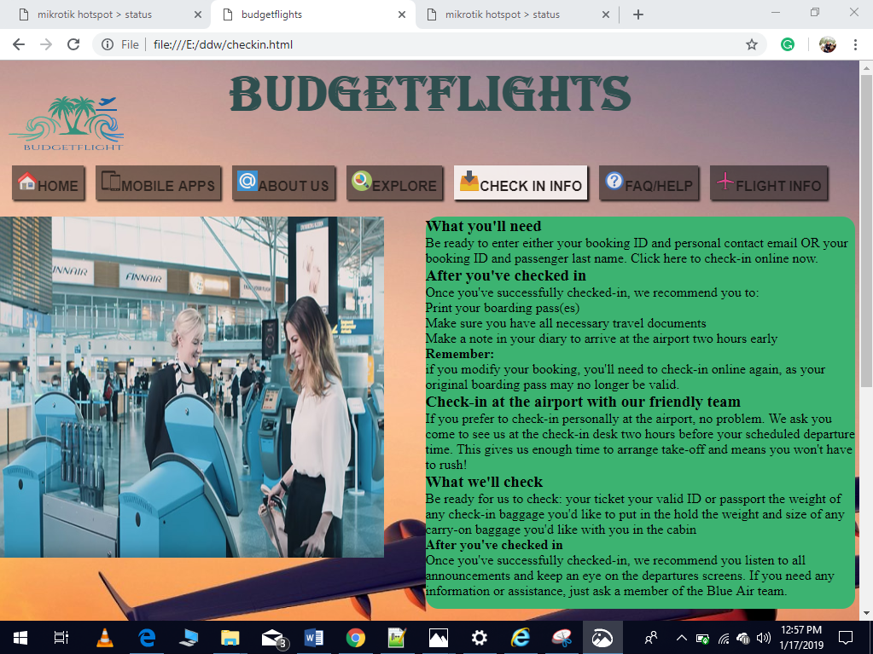

Figure : Screenshot of check-info in google chrome

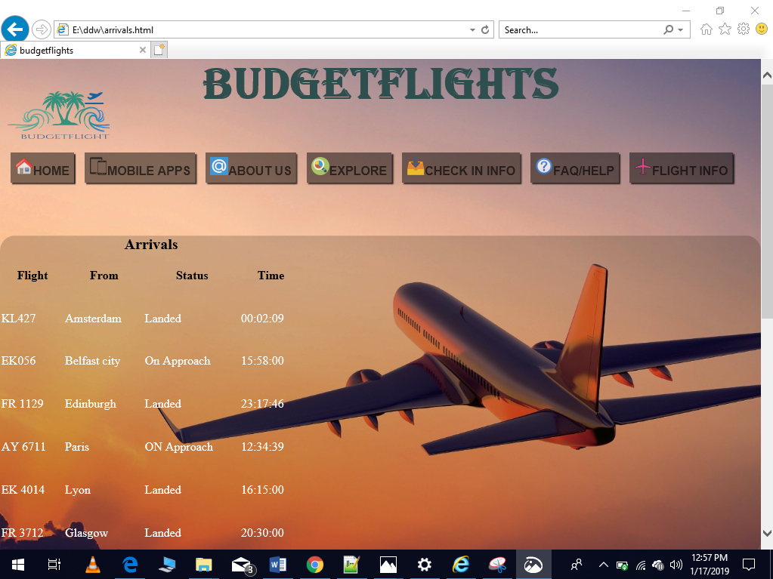

Figure : Screenshot of arrival in internet explorer

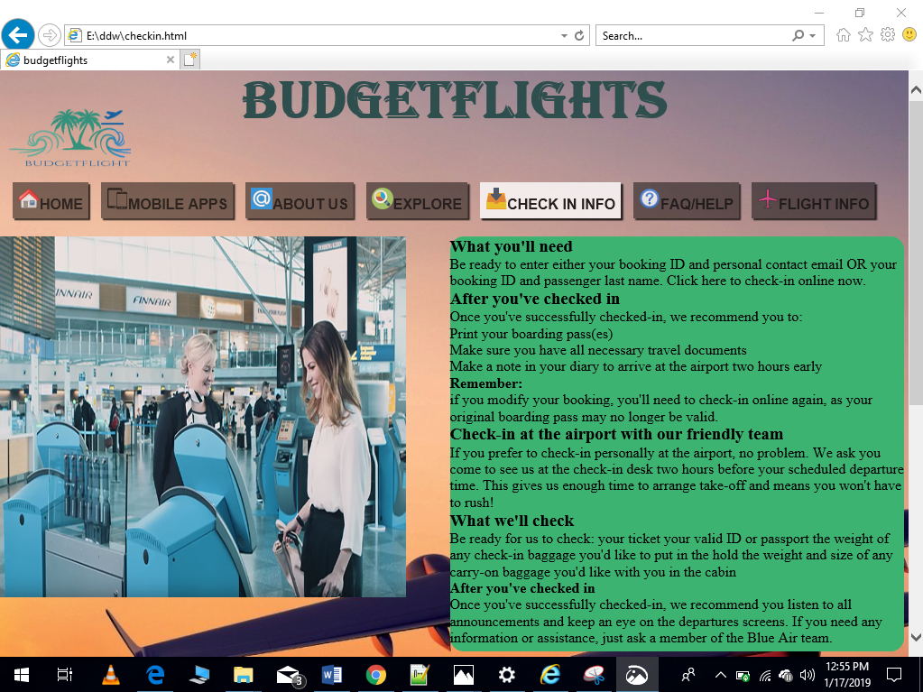

Figure : Screenshot of check-info in internet explorer

## Explain if there is any difference in the outputs (in two browsers). You can explain about the problems you have faced while checking in different browsers. If you find any problems, provide a description of any outstanding problems and recommendations for fixing them.

After developing a website, browser testing plays an important role because the appearance of the website may be different in other browsers. While testing my developed website on internet explorer, Mozilla Firefox and chrome, I found a horizontal bar appearing in internet explorer and Mozilla Firefox but not in chrome. Date time attributes are not supported by all above browsers. Multimedia file is supported by only some browser.

**Problems and Recommendations:**

* I found that website loading is poor in internet explorer as compare to google chrome.so, I used different attributes to load website faster than before.
* I found internet explorer was displaying horizontal bar, so I used a media query to solved horizontal scrolling bar in 1024*768 resolution.
* Date time was warning on both Internet Explorer and chrome, so I used Mozilla Firefox to check whether the problems repeated or not. But still, the problem arises.
* Internet Explorer didn’t support all multimedia file so, I have used google chrome instead of it and also I replaced media file type for opera in my website.

# Task 4

# Analysis of the website

My website “Budget Flight” is a flight booking site which helps people to book flights across Europe and many other continents of the globe. My website helps clients to use and search cheap flights and also provides offers to the clients. My website also gives information to clients about the popular places across Europe. This website contains links to mobile apps, windows and iOS. Users can check flights arrival and departure from flight info web page. In this website, customers can take help of FAQ or help page to know different details about the budget flight.

## Effectiveness of the CSS for the hover able horizontal navigation bar

Hover able horizontal navigation bar are effective as follow:

* It makes the navigation bar more attractive.
* It make the webpage user friendly.

## Evaluation of the passenger drop-down list and options

* It helps customers to book the number of person or flights
* They can select number of people just clicking on passenger drop-down list without typing.

## Advantages and disadvantages of various types of multimedia file formats

Advantages of multimedia file:

* Multimedia file are recommendation faster by search engine
* User-friendly
* Multimedia can be used to make a website dynamic and attractive.

Disadvantages of multimedia file:

* Webpage size will be heavier
* Webpage loading time increases
* The browser might not support multimedia file. (Smallbusiness.chron.com, 2019)

## Advantages and disadvantages of different types of multimedia elements in relation to different contexts

Advantages of multimedia elements are:

* It makes the web pages to look attractive.
* It provides information through video and audio to uneducated people.
* Multimedia can be used for educational purposes.

Disadvantages of multimedia elements are:

* Information overloaded
* Not always compatible
* It occupies more size.

## Advantages and disadvantages aspects of your website, suggest improvements, and propose ideas for further development.

Advantages aspects of my websites are:

* User can search flight
* They can take details information of flight
* Website is more user-friendly

Suggestion for improvements:

* A responsive website should be made
* Multimedia contains large size file so, it should be resized

Further development ideas:

* Web pages must be compatibility on a different device, screen and version.

## Conclusion

In some web pages, I have used media query code to make screen compatibility on 1024×786 and different multimedia file were used to make a more attractive and user-friendly website. Finally, I got success to develop a budget flight website according to the given scenario to me.

# References

Smallbusiness.chron.com. (2019). *Advantages & Disadvantages of Using Multimedia on Web Pages*. [online] Available at: https://smallbusiness.chron.com/advantages-disadvantages-using-multimedia-pages-46642.html [Accessed 18 Jan. 2019].

Solutions, S. (2019). *The 5 Types of Digital Image Files: TIFF, JPEG, GIF, PNG, and Raw Image Files, and When to Use Each One*. [online] The IvanExpert Mac Blog. Available at: https://www.ivanexpert.com/blog/2010/05/the-5-types-of-digital-image-files-tiff-jpeg-gif-png-and-raw-image-files-and-when-to-use-each-one/ [Accessed 18 Jan. 2019].

TO THE NEW BLOG. (2019). *Advanced Features of HTML5 and CSS3 | TO THE NEW Blog*. [online] Available at: http://www.tothenew.com/blog/advanced-features-of-html5-and-css3/ [Accessed 18 Jan. 2019].